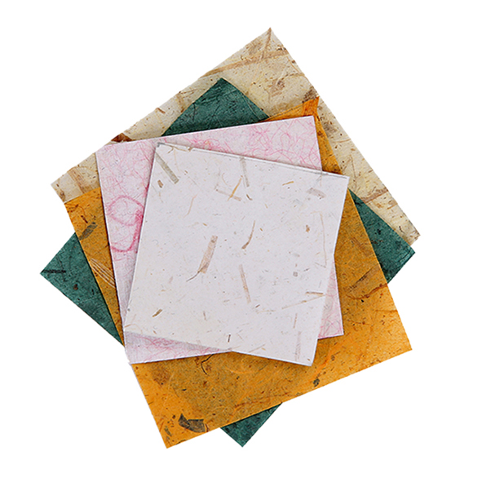

ASSOCIATION OF CYPRUS PAPER ARTISTS

MEMBERSHIP APPLICATION FORM
2016

Name and Surname:

National I.D. Number:

Place of Residency and address:

Telephone:

Fax:

Mobile Number:

E-mail:

Website:

Date of Application:

Please mark [x] the category that best reflects your occupation/interest:

[ ] Paper Artist
[ ] Paper Maker
[ ] Book Artist
[ ] Workshop
[ ] Visual Arts Student
[ ] Academic Member
[ ] Art lover
[ ] Art Historian
[ ] Curator
[ ] Manager
[ ] Conservator
[ ] Art Collector
[ ] Paper Industry
[ ] Other .....................

MEMBERSHIP PROCEDURE:

Annual Fee: 150TL

To complete your membership application please fill in and sign this form and return to the following E-mail address with three paper art works: kksd.cyp@gmail.com

DECLARATION

I hereby confirm that I have read and comply by the membership rules and procedures, and declare my membership application to the Association of Cyprus Paper Artists.

Name:

Signature / Date:

